

Project Development Phase Delivery of Sprint-1

|  |  |
| --- | --- |
| **Date** | 03.11.2022 |
| **Team Id** | PNT2022TMID53357 |
| **Project Name** | AI Based Discourse for Banking Industry |

Greetings:

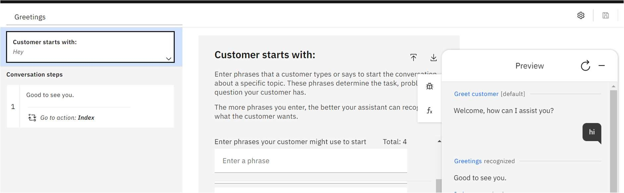

Creation of Account or Application:

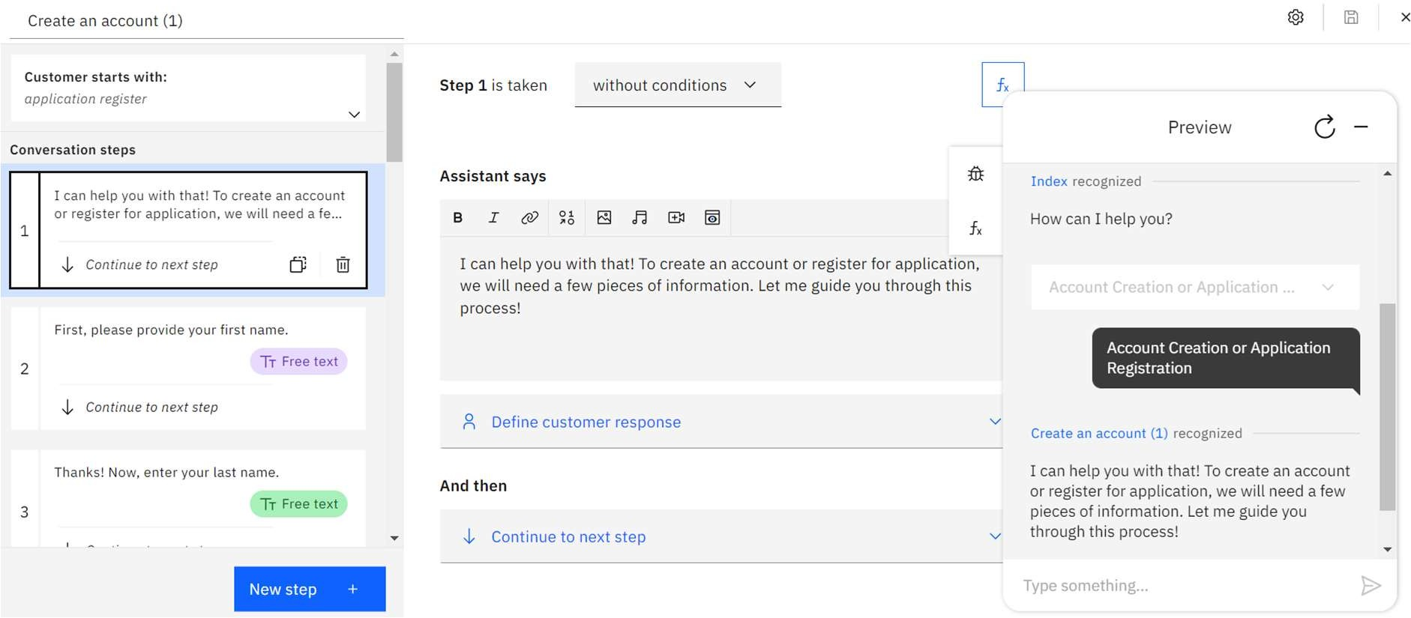



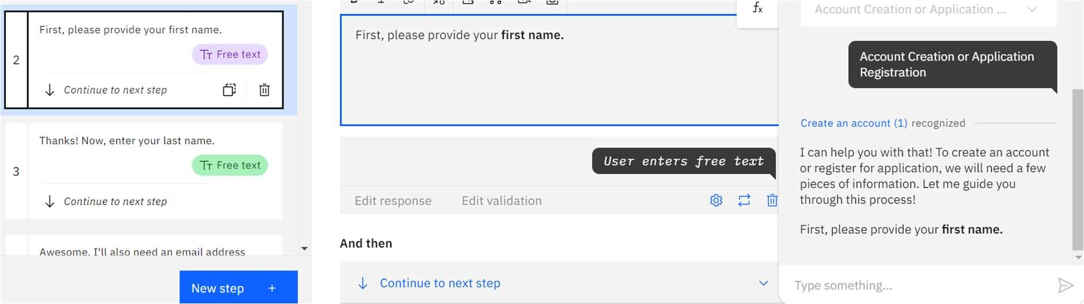

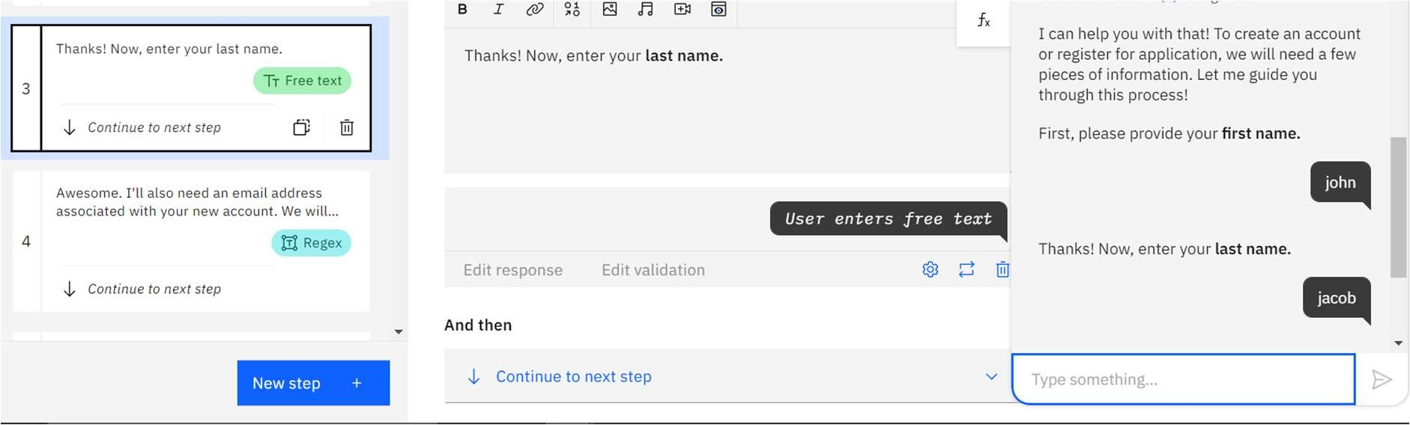

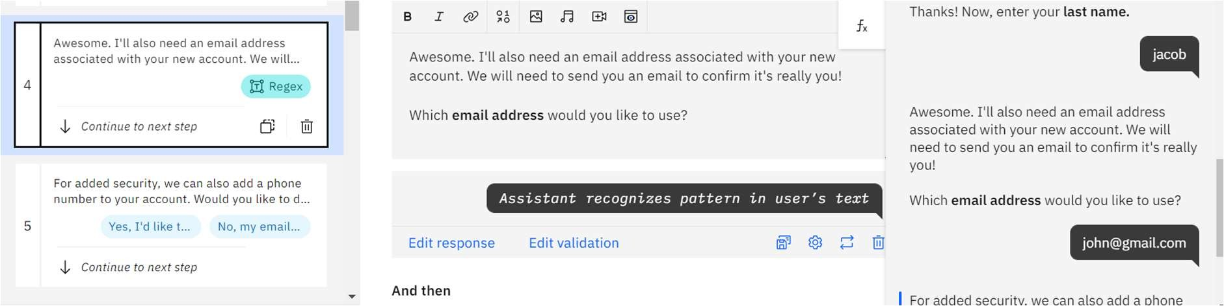

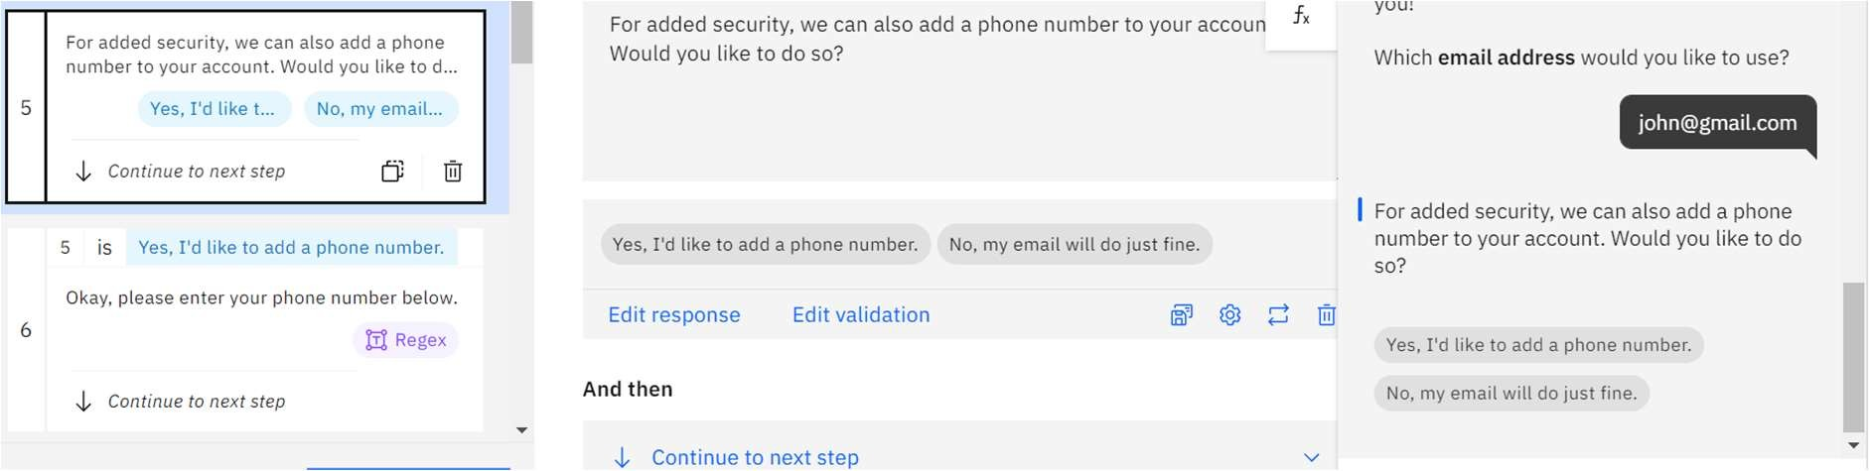



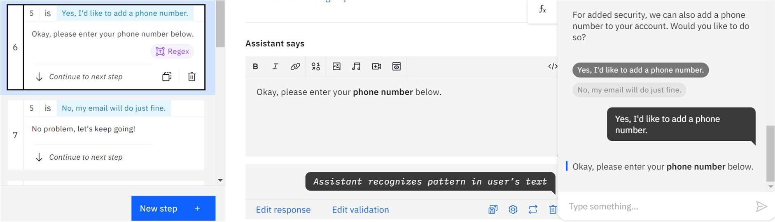

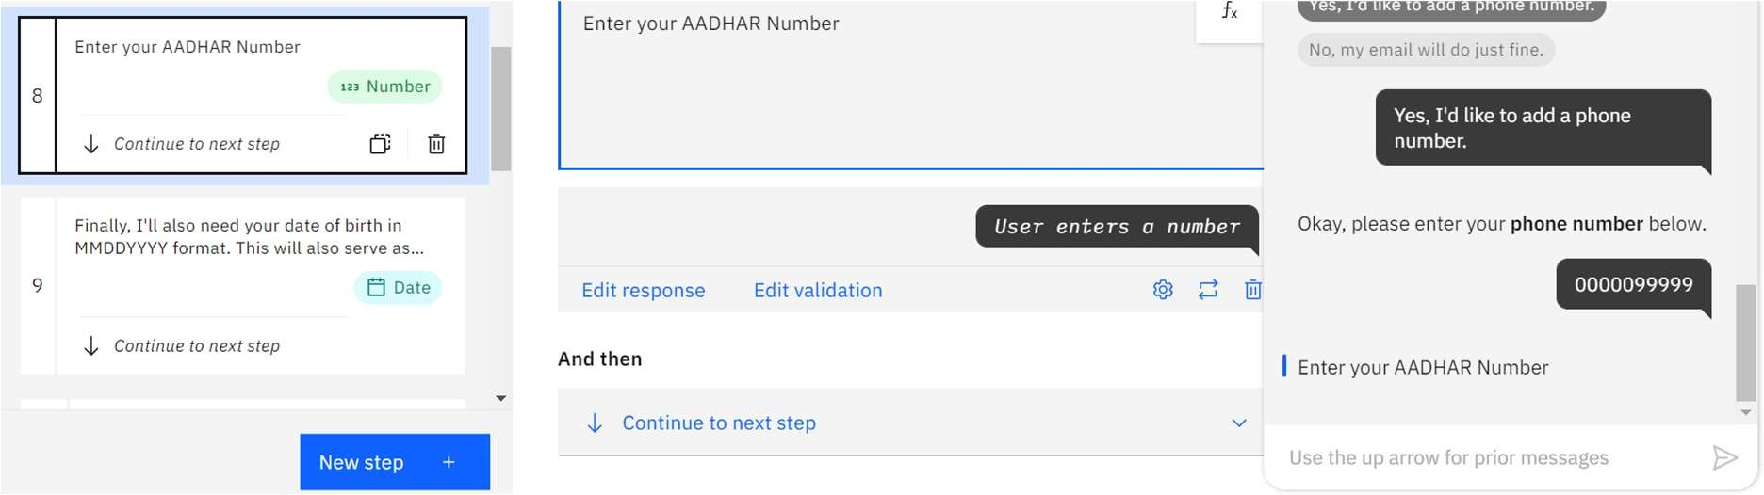

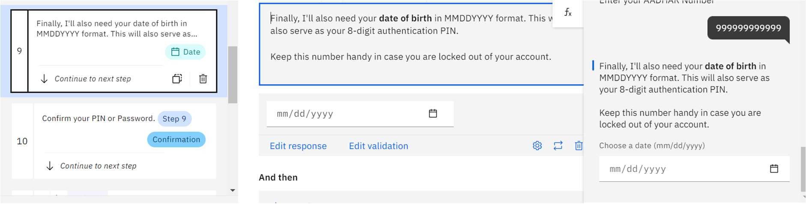

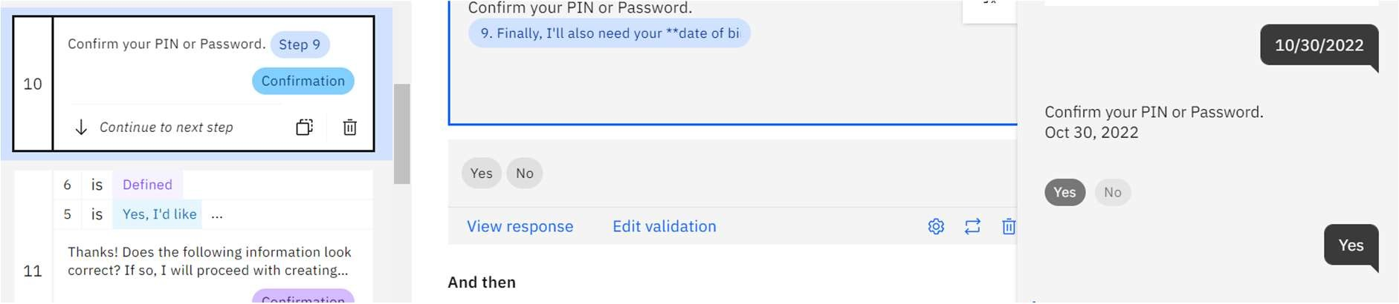

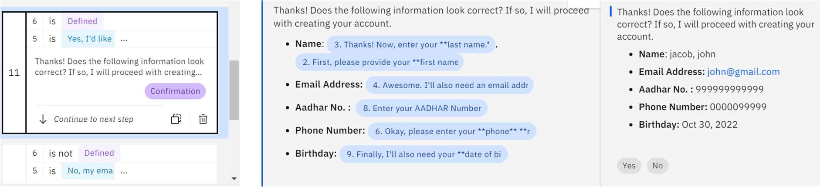



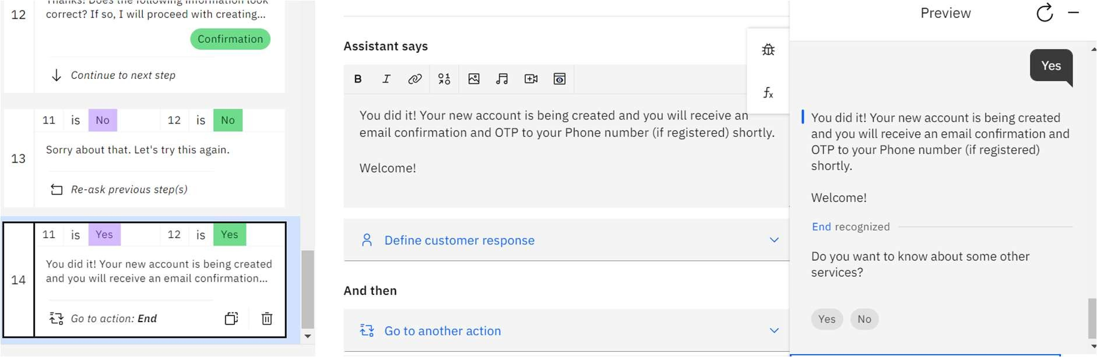

User Login:

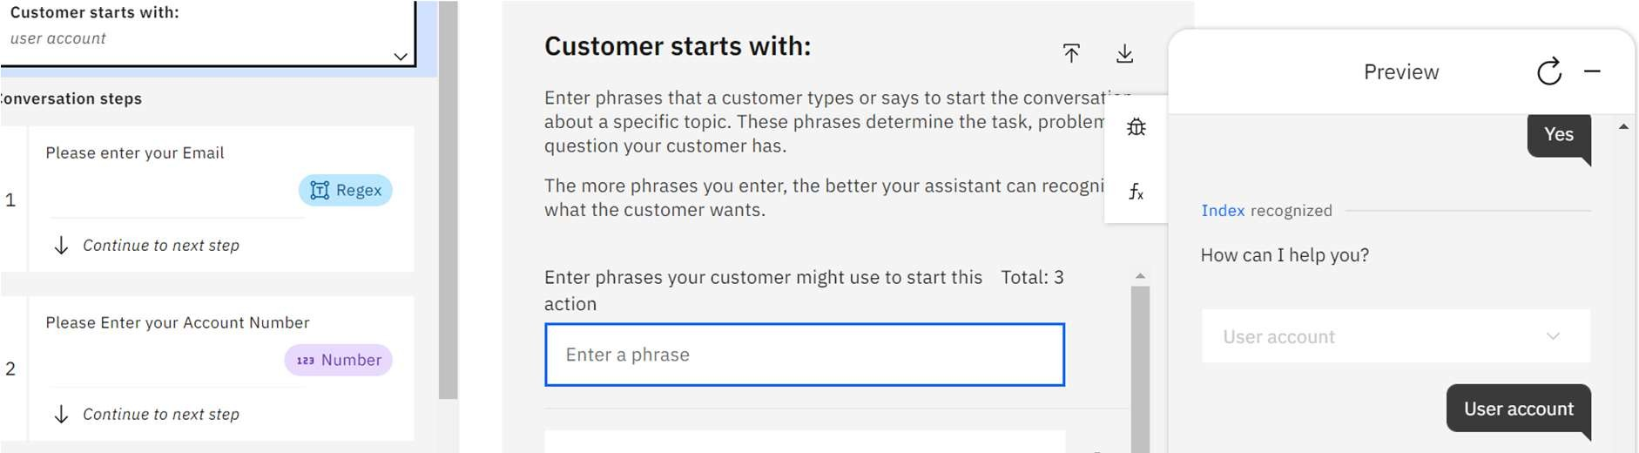

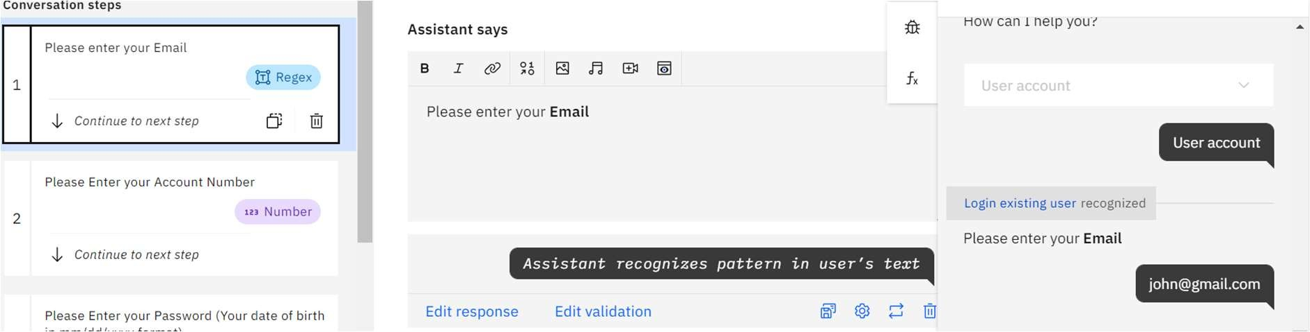

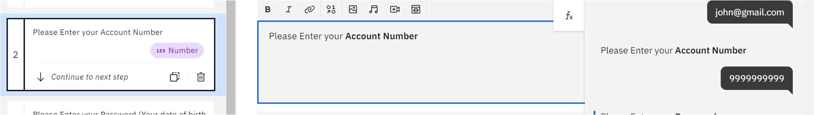



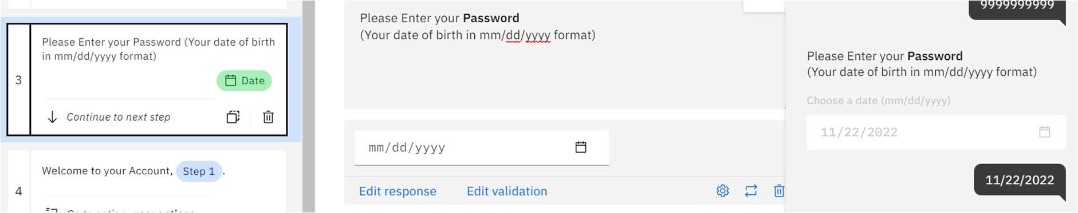

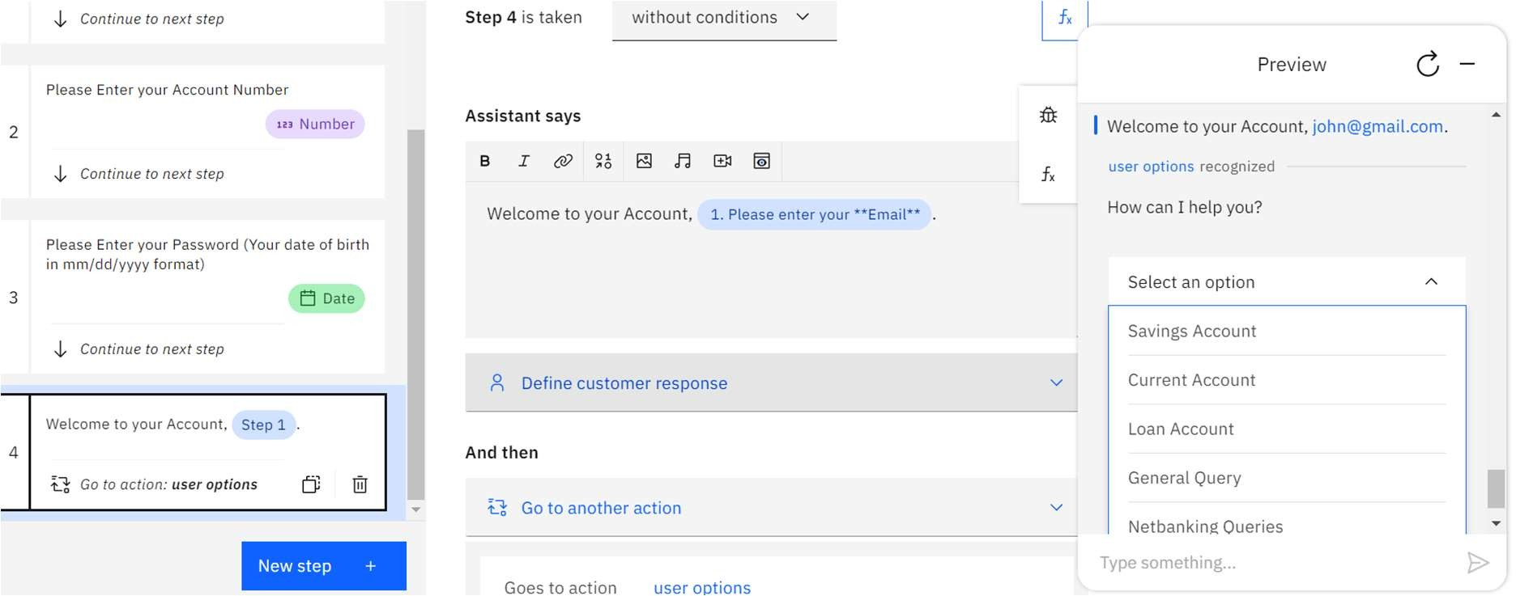

Admin Controls:

